Codelab RESUBMISSION(DATA DRIVEN APPLICATION) .

Name: Muhamad Mueez Amer Iqbal

Student Number : 415772

Description:

We have been approached to build up an application that cross examines tweets. We have two alternatives for finishing this task. For the two choices the application ought to be intended to utilize capacities, and pass contentions between these as proper. Where conceivable the application ought to be likewise executing object arranged programming techniques. The last application have to be conveyed through a working intuitive GUI fabricated utilizing open Frameworks. This GUI ought to permit the client to communicate by means of mouse or potentially console input. The GUI is also included in it and the open frame work is also there with the code. The code is viewable and run able. Shows all the function of the commands mentioned there.

There are Six models that have effectively been given to us and four more should be implemented by us. The six are as below:

• Count the quantity of tweets in the organizer

• Counting the quantity of tweets which includes "Money"

• Counting the quantity of tweets which includes "Politics"

• Printing on the screen any tweets which includes "Paris"

• Printing on the screen any tweets which includes "Dreamworks"

• Printing on the screen any tweets which includes "Uber"

And the other Four are as below:

* Counting the quantity of tweets which includes “Elections”.
* Counting the quantity of tweets which includes “Specific UK”.
* Printing on the screen any tweets which includes “BreakingNews”.
* Printing on the screen any tweets which includes “Hometown”.

**Project Idea:**

**Going on with a essential week and a bit of cycle have been played to incorporate the organizing of points , taking where to run certain frameworks that would be added on the main movement in the Better results of the application. Thinking that it would, Steps should to be taken in consideration for addressing individuals and represent what would be needed for the application to fulfil its requirements. At whatever point this is finished, some models or example can be drawn up that get ready for the executing PC programs is to be in progress.**

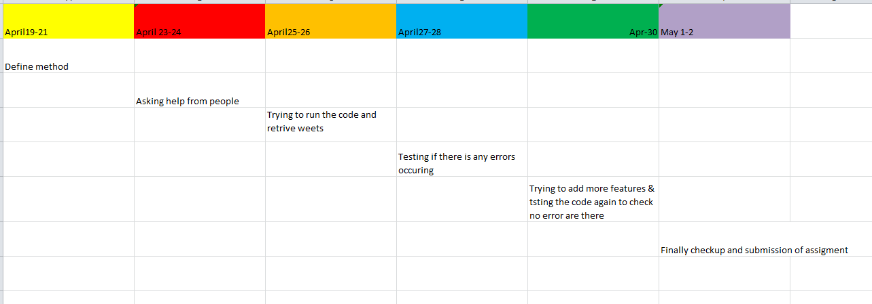

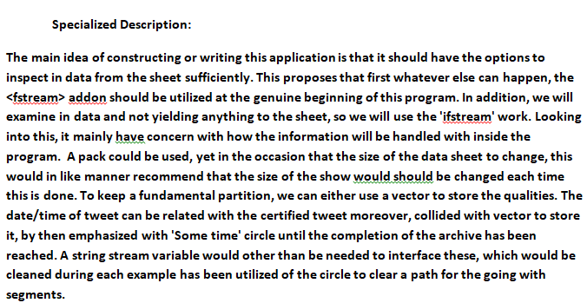

CODE:

#include<iostream>

#include<fstream>

#include<string.h>

#include<vector>

#include<string>

using namespace std;

int main()

{

int count = 0, i;

string line;

int a;

string stopApp;

string hometowntweetHolder;

vector<string> hometowntweet, hometowntweetHolder2;

int hometowncount1 = 0;

string UbertweetHolder;

vector<string> Ubertweet, UbertweetHolder2;

string DreamWorkstweetHolder;

vector<string> DreamWorkstweet, DreamWorkstweetHolder2;

string hashtagtweetHolder;

vector<string> hashtagtweet, hashtagtweetHolder2;

string specificUsertweetHolder;

vector<string> specificUsertweet, specificUsertweetHolder2;

int count1 = 0;;

string locationtweetHolder;

vector<string> locationtweet, locationtweetHolder2;

int count2 = 0;

string DonaldtweetHolder;

vector<string> Donaldtweet, DonaldtweetHolder2;

string BreakingNewstweetHolder;

vector<string> BreakingNewstweet, BreakingNewstweetHolder2;

string sepIssuetweetHolder;

vector<string> sepIssuetweet, sepIssuetweetHolder2;

string augusttweetHolder;

vector<string> augusttweet, augusttweetHolder2;

string UKtweetHolder;

vector<string> UKtweet, UKtweetHolder2;

string christmastweetHolder;

vector<string> christmastweet, christmastweetHolder2;

int christmascount1 = 0;

fstream data10("sampleTweets.csv");

if (data10.is_open())

{

while (!data10.eof())

{

getline(data10, hometowntweetHolder);

hometowntweet.push_back(hometowntweetHolder);

}

data10.close();

}

else

{

cout << "not found" << endl;

}

ifstream file("sampleTweets.csv");

ifstream data9("sampleTweets.csv");

if (data9.is_open())

{

while (!data9.eof())

{

getline(data9, UbertweetHolder);

Ubertweet.push_back(UbertweetHolder);

}

data9.close();

}

else

{

cout << "not found" << endl;

}

ifstream data8("sampleTweets.csv");

if (data8.is_open())

{

while (!data8.eof())

{

getline(data8, DreamWorkstweetHolder);

DreamWorkstweet.push_back(DreamWorkstweetHolder);

}

data8.close();

}

else

{

cout << "not found" << endl;

}

ifstream data("sampleTweets.csv");

if (data.is_open())

{

while (!data.eof())

{

getline(data, hashtagtweetHolder);

hashtagtweet.push_back(hashtagtweetHolder);

}

data.close();

}

else

{

cout << "not found" << endl;

}

ifstream data1("sampleTweets.csv");

if (data1.is_open())

{

while (!data1.eof())

{

getline(data1, specificUsertweetHolder);

specificUsertweet.push_back(specificUsertweetHolder);

}

data1.close();

}

else

{

cout << "not found" << endl;

}

ifstream data2("sampleTweets.csv");

if (data2.is_open())

{

while (!data2.eof())

{

getline(data2, locationtweetHolder);

locationtweet.push_back(locationtweetHolder);

}

data2.close();

}

else

{

cout << "not found" << endl;

}

ifstream data3("sampleTweets.csv");

if (data3.is_open())

{

while (!data3.eof())

{

getline(data3, DonaldtweetHolder);

Donaldtweet.push_back(DonaldtweetHolder);

}

data3.close();

}

else

{

cout << "not found" << endl;

}

ifstream data4("sampleTweets.csv");

if (data4.is_open())

{

while (!data4.eof())

{

getline(data4, BreakingNewstweetHolder);

BreakingNewstweet.push_back(BreakingNewstweetHolder);

}

data4.close();

}

else

{

cout << "not found" << endl;

}

ifstream data5("sampleTweets.csv");

if (data5.is_open())

{

while (!data5.eof())

{

getline(data5, sepIssuetweetHolder);

sepIssuetweet.push_back(sepIssuetweetHolder);

}

data5.close();

}

else

{

cout << "not found" << endl;

}

ifstream data6("sampleTweets.csv");

if (data6.is_open())

{

while (!data6.eof())

{

getline(data6, augusttweetHolder);

augusttweet.push_back(augusttweetHolder);

}

data6.close();

}

else

{

cout << "not found" << endl;

}

ifstream data7("sampleTweets.csv");

if (data7.is_open())

{

while (!data7.eof())

{

getline(data7, UKtweetHolder);

UKtweet.push_back(UKtweetHolder);

}

data7.close();

}

else

{

cout << "not found" << endl;

}

do {

cout << endl << "....................................Menu...................................." << endl;

cout << endl << "Press Number Which operation you want!" << endl;

cout << "1-Count the total number of tweets in the data set" << endl;

cout << "2-Count the number of tweets that include money" << endl;

cout << "3-Count the number of tweets that include politics" << endl;

cout << "4-Print to the screen any tweets that include Paris " << endl;

cout << "5-Print to the screen any tweets that include DreamWorks " << endl;

cout << "6-Print to the screen any tweets that include Uber " << endl;

cout << "7-Display tweets about Election " << endl;

cout << "8-Display specific UK tweets " << endl;

cout << "9-Display Breaking News tweets " << endl;

cout << "10-Total number of hometown tweets" << endl;

cin >> a;

switch (a)

{

case 1:

cout << endl << "...............1-Total Number of tweets in data set...................." << endl;

while (getline(file, line))

{

count++;

}

cout << "1-Total Numbers of Tweets in the file : " << count << endl;

break;

case 2:

cout << endl << "................2-Count the number of tweets that include money..........." << endl;

for (int j = 0; j < specificUsertweet.size(); j++)

{

string str2 = specificUsertweet[j];

if (str2.find("money") != string::npos)

{

specificUsertweetHolder2.push_back(specificUsertweet[j]);

//cout<<endl<<specificUsertweet[j]<<endl;

count1++;

}

}

cout << "2-Total Numbers of Tweets that include money are : " << count1 << endl;

break;

case 3:

cout << endl << ".......................3-Count the number of tweets that include politics........................... " << endl;

for (int k = 0; k < locationtweet.size(); k++)

{

string str3 = locationtweet[k];

if (str3.find("politics") != string::npos)

{

locationtweetHolder2.push_back(locationtweet[k]);

//cout<<endl<<locationtweet[k]<<endl;

count2++;

}

}

cout << "3-Total Numbers of Tweets that include politics are : " << count2 << endl;

break;

case 4:

cout << endl << ".......................4-Print to the screen any tweets that include Paris........................... " << endl;

for (int k = 0; k < locationtweet.size(); k++)

{

string str3 = locationtweet[k];

if (str3.find("paris") != string::npos)

{

locationtweetHolder2.push_back(locationtweet[k]);

cout << endl << locationtweet[k] << endl;

}

}

break;

case 5:

cout << endl << "...............5-Display tweets that include DreamWorks...................." << endl;

for (int i = 0; i < DreamWorkstweet.size(); i++)

{

string str1 = DreamWorkstweet[i];

if (str1.find("DreamWorks") != string::npos)

{

DreamWorkstweetHolder2.push_back(DreamWorkstweet[i]);

cout << endl << DreamWorkstweet[i] << endl;

//moneycount1++;

}

}

break;

case 6:

cout << endl << "...............6-Display tweets that include uber...................." << endl;

for (int i = 0; i < Ubertweet.size(); i++)

{

string str1 = Ubertweet[i];

if (str1.find("Uber") != string::npos)

{

UbertweetHolder2.push_back(Ubertweet[i]);

cout << endl << Ubertweet[i] << endl;

//moneycount1++;

}

}

break;

case 7:

cout << endl << "...............7-Display tweets about election...................." << endl;

for (int i = 0; i < augusttweet.size(); i++)

{

string str1 = augusttweet[i];

if (str1.find("election") != string::npos)

{

augusttweetHolder2.push_back(augusttweet[i]);

cout << endl << augusttweet[i] << endl;

//moneycount1++;

}

}

break;

case 8:

cout << endl << "...............8-Display specific UK tweets...................." << endl;

for (int i = 0; i < UKtweet.size(); i++)

{

string str1 = UKtweet[i];

if (str1.find("UK") != string::npos)

{

UKtweetHolder2.push_back(UKtweet[i]);

cout << endl << UKtweet[i] << endl;

//moneycount1++;

}

}

break;

case 9:

cout << endl << "...............9-Display Breaking News Tweets...................." << endl;

for (int i = 0; i < BreakingNewstweet.size(); i++)

{

string str1 = BreakingNewstweet[i];

if (str1.find("breaking news") != string::npos)

{

BreakingNewstweetHolder2.push_back(BreakingNewstweet[i]);

cout << endl << BreakingNewstweet[i] << endl;

//moneycount1++;

}

}

break;

case 10:

for (int j = 0; j < hometowntweet.size(); j++)

{

string str8 = hometowntweet[j];

if (str8.find("hometown") != string::npos)

{

hometowntweetHolder2.push_back(hometowntweet[j]);

//cout<<politicstweet[j]<<endl;

hometowncount1++;

}

}

cout << endl << "10-Total number of hometown tweets= " << hometowncount1 << endl;

break;

}

cout << "Do you want to continue? (Y/N)" << endl;

cin >> stopApp;

} while (stopApp == "Y");

return 0;

**RESULT OF CODING:**

....................................Menu....................................

Press Number Which operation you want!

1-Count the total number of tweets in the data set

2-Count the number of tweets that include money

3-Count the number of tweets that include politics

4-Print to the screen any tweets that include Paris

5-Print to the screen any tweets that include DreamWorks

6-Print to the screen any tweets that include Uber

7-Display tweets about Election

8-Display specific UK tweets

9-Display Breaking News tweets

10-Total number of hometown tweets

................2-Count the number of tweets that include money...........

2-Total Numbers of Tweets that include money are : 65

Do you want to continue? (Y/N) .

**NOTE: PLEASE USE CAPITAL Y or N for running the program Y stands for Y to continue & N for discontinue**

**The GitHub link is attached:** [**https://github.com/MuhammadMueezA/CODELABRESUBMISIION**](https://github.com/MuhammadMueezA/CODELABRESUBMISIION)

**If the GitHub link does not work then you can check in google drive:**

**For Code:** [**https://drive.google.com/file/d/1DHakatGt3Uo-RTxQJhjkfvZ0DqELzEuh/view?usp=sharing**](https://drive.google.com/file/d/1DHakatGt3Uo-RTxQJhjkfvZ0DqELzEuh/view?usp=sharing)

**Running file:** [**https://drive.google.com/file/d/1-E6qGtdhV-WFJ762Yje_RbzIWEOSC1vj/view?usp=sharing**](https://drive.google.com/file/d/1-E6qGtdhV-WFJ762Yje_RbzIWEOSC1vj/view?usp=sharing)**.**

**Please click above link for running file .**